Aug 7 2025 BDBP106: Linux and Python programming Lab 6
Ankita Bose, PhD
1) The echo command can be used simply to display a piece of text (useful in programs).
Use echo to create a sentence. Pipe the output of this command to count the number of
words in the sentence. How do I use the wc to count the number of lines in this sentence?

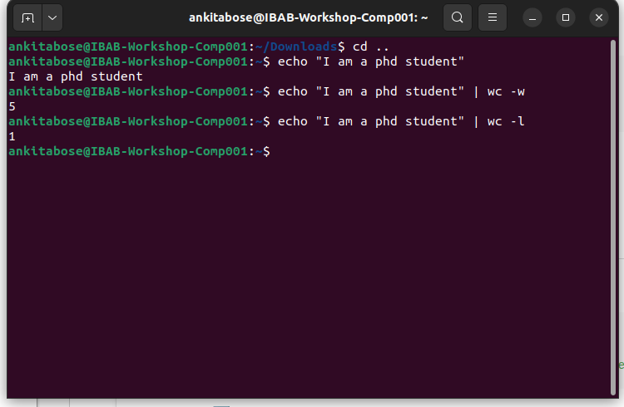
To count the number of lines in the sentence we use the command wc -l

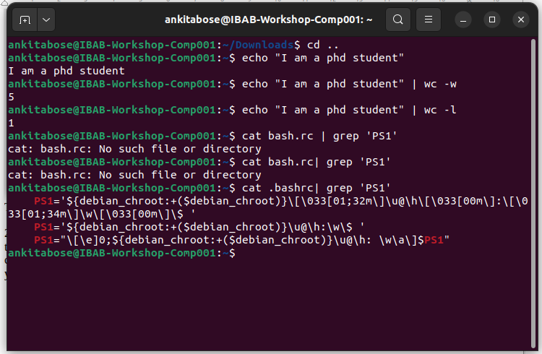
2) Execute the following command, and explain the meaning of the output. This concerns the appearance of the command prompt, and you should be able to dissect the output completely and explain it part by part. Make a list of the parts of the output and write your explanations against each part. The command is cat .bashrc | grep ’PS1’

The cat .bashrc command displays the lines/contents of the bashrc file that is the shell configuration file which contains PS1 represented as red colour wh has the string PS1. The code for the green text colour is also represented here along with the representation of the full working directory path.

(3) In the above exercise, filter the output based on ’HIST’ pattern. You will see a list environment variables. Figure out what they stand for and what the current values
mean.

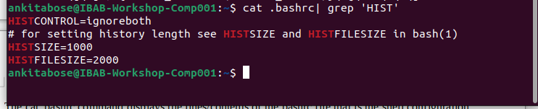
HIST command represents the History command. HISTSIZE represents the number of commands stored in the memory, where 1000 are the most recent ones. HISTFILESSIZE is the maximum number of commands saved in bash_history file. HISTCONTROL ignores the duplicate commands that are stored.

4) The whereis command searches for a program in a predefined set of standard binary drectories such as /bin, /usr/bin and /usr/sbin. Type whereis ls and study the output What is the difference between which and whereis commands?
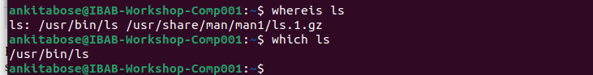
“which” command shows the location of the executable frim directories in current path and “whereis” locates the man page file for a given command and looks in a predefined set of directories and not the user’s path only

5) The command dirname is used to retrieve the directory name in a given file path. Nav-
igate to a previous lab folder such as Lab4 and list the files. Then type the command
dirname <filename> where give some existing filename in this command. What is the
output?
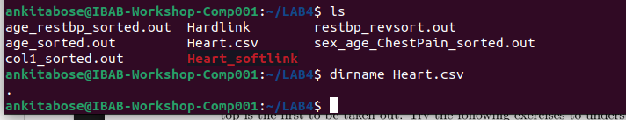

6) Create a local variable called mylabdir, and set it to the following value: /home/ibab/Lab6
(which means that if you have not created a Lab6 folder you should do so). Print the
value of this variable using the echo command, and then the dirname command output
with a file you are working with, under the Lab6 directory.

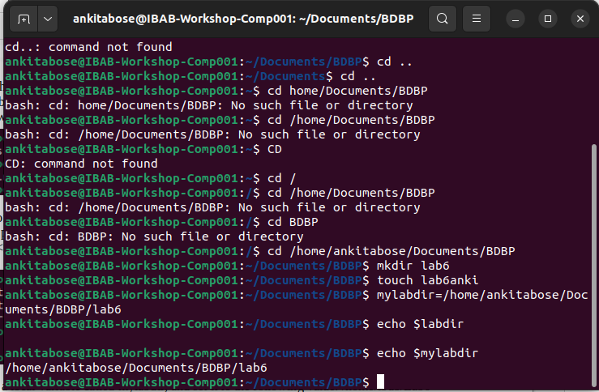
(7) Create a new bash subshell in this terminal. Prove that you have created a subshell
using the ps command with the appropriate options. Inside this subshell print the value
of the variable mylabdir. What is the value? If it is empty, how do you convert it to a
global variable? Do the conversion and show that mylabdir is indeed a global variable.

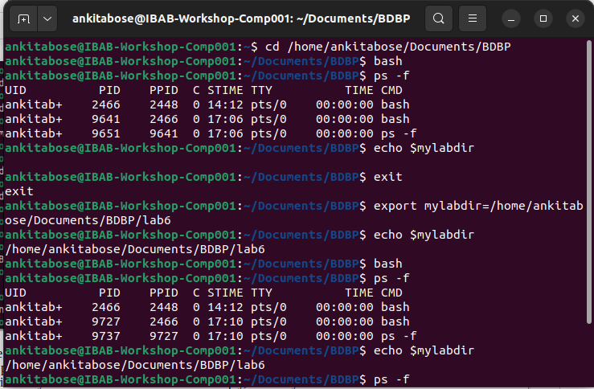
(8) Display the output of the command echo $PATH. Is PATH local or global variable? De-
scribe two ways of finding this out.
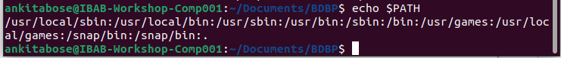
Path is a global environmental variable. Another way of seeing this is by printing the path in parent and child-subshell

(9) The concept of a directory stack. Learning about this will allow you to know the powerful
navigation mechanisms in Linux. The key commands in this exercise are dirs,cd -,
pushd and popd. The directory stack operates like a stack of plates – the last plate on
top is the rst to be taken out. Try the following exercises to understand this.
(i) Execute dirs -v -l. What is the output? Learn more about the command
and the options by looking up the man pages of what these options did. For
each command below execute dirs -v -l to understand what happened to the
directory stack.
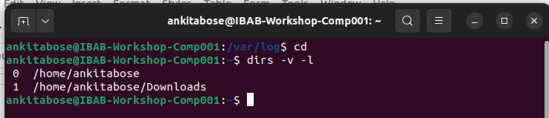

(ii) By default the directory stack contains only one entry – the path to your $HOME.
Let’s add some entries to this stack using the following commands:
(a) pushd /var/log
(b) pushd /tmp
(c) pushd /etc
(d) pushd ~/Downloads
(e) pushd ~/Documents
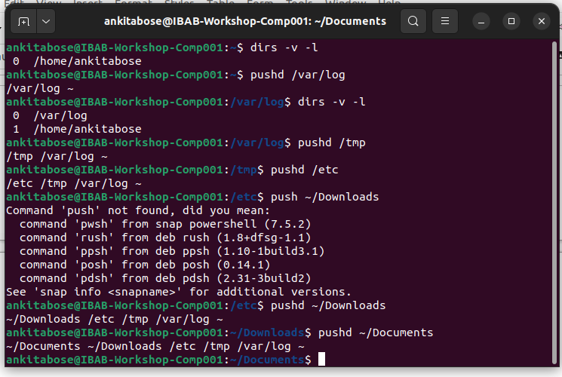
iii) Now execute dirs -v -l again. Explain the output.
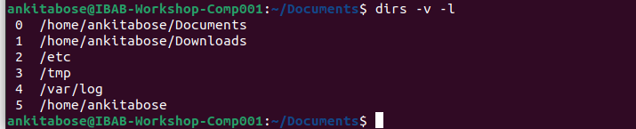
It shows a long list along with the directory paths and index numbers of each. The number 0,1,2 etc is the stack positions (0=current directory).
iv) Execute the command pushd +1. Explain what happened.

pushd rotates the directory stack and changes to the directory at the given position. +1 means “the directory in stack position 1”. Hence the chosen directory becomes the current directory.

v) Execute cd -. What happened?
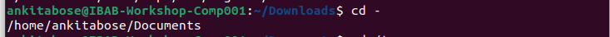
This command took us back to the previous directory we were in.

vi) Execute cd /tmp. What happened? In this case, note that we simply changed
directory to an entry in the directory stack without reference to the stack in any
way.
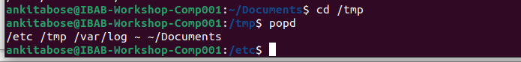
vii) Execute popd. What happened? popd is responsible for removing the topmost
plate in the stack and changes to the directory entry against index 1.
viii) Execute popd +2. What happened? How is this different from pushd +2?
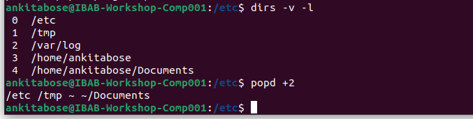
pushd +2 rotates the directory stack so that the directory at position +2 becomes the current one, moving the old current directory down in the stack. Popd +2 removes the directory at position +2 from the stack without changing the current directory

(ix) In all the above, what was happening the entry that was indexed against ’0’ ?
Explain what this entry represents.
The entry indexed as 0 represents the current workind directory. When we run pushd, the directory at position 0 changes because you switch to another directory (and the old 0 is pushed down the stack). When we run popd 0 the current directory is removed, and the shell immediately changes into the new 0.

